**The Website Bible**

# Waterfall Model (paramount importance)

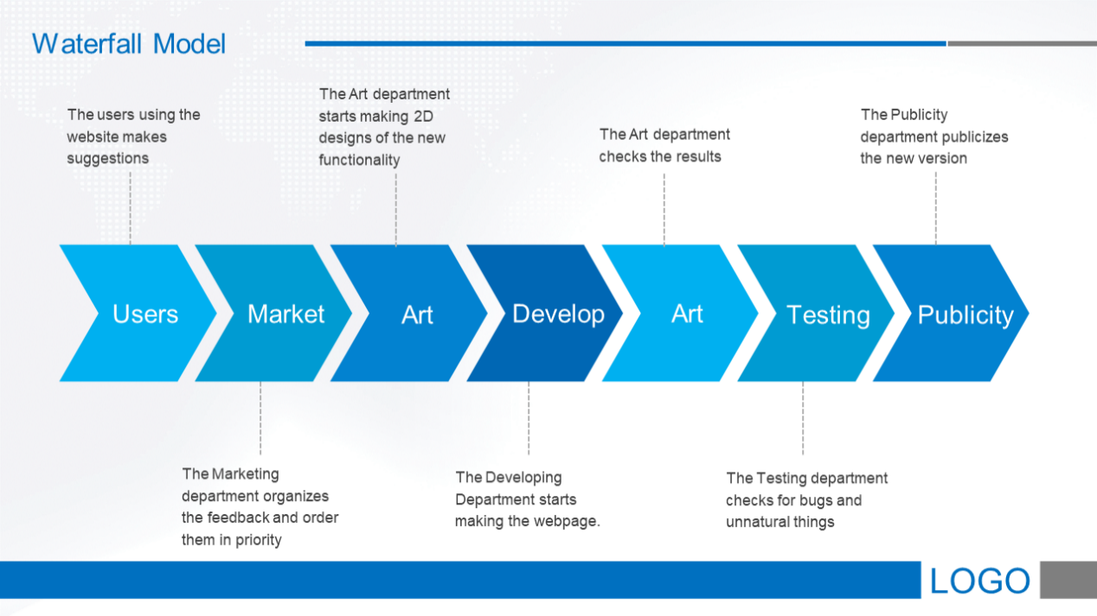

Development Cycle (MEMORIZE IT!!!)

# Departments

## Overall leaders

Tiger: Leader, CTO

Brian: Deputy leader

## Art

The department that handles the poster designs and website UI designs, please always refer to the waterfall model for more detail.

Members:

- Mike

- Veronica

- Sonia

- Kathy

- Mimi

## Development

The department that develops and maintains the system. Core.

Members:

- Michel

- Alex He

- Sophia Zhu

## Publicity

Focuses on the publicity of the website (self-explanatory), including writing things, making posters with the Art, and doing speeches.

Members:

- Kathy

- Nick

- Mike

- Harrison

- Hazel

- Oscar

- Alice

- Eddie

- Lucy

- Alex Zhao

- Ian

## Feedback

Collects the feedback from the website users and compiles them into a report every month. Starting in November since October will be the first month.

Members:

- Alex Xu

- Jerry

- Eric Hu

## Testing

Tests the website before major releases, makes sure there is no bugs, weird UI, and unnatural interactions.

Members:

- Lucy

- Alex Xu

- Harrison

- Alex Zhao

- Oscar

# Tasks

## Current Ongoing

#### Primary Publicity

Most import act in the coming weeks.

Includes:

1. Make a poster for publicity and print it out
2. Prepare a PA lecture & assembly speech
3. Register a 公众号 and write the first writing to introduce and publicize the website

#### Phone Adaptation

The development will adapt the current website to the phone screen size.

1. Format the UI with bootstrap
2. Add retractable menu

#### Bulletin Board

An area that we can post announcements targeted to the website users about ourselves or other important notices.

#### Website UI

Design the website UI for the bulletin board. First task, a kind of practice in 2D design.

## Past Completed

#### Basic Framework

A functional website that is usable.

#### Departments Foundation

The foundation of different departments.

#### Domain Registration

Register a domain name.

#### Real-time update

The crawler synchronizing system currently only has the manual system, adds a periodic update mechanism to show real-time info.

# Future Plans

## Collegepedia

An idea from Chen Lin teacher (citing sources).

Everyone can upload their college research on the website and share with others, might gain service hrs and points (that can be turned into small rewards).

## PubCharity

An idea from Wu Chen director (citing sources).

We can collaborate with charity groups to post their publications on the website, helping them gain support.

#### A-Level announcements

Crawl for A-Level students as well.